**IBENTO**

EVENTS MADE EASIER



**Abstract**

For simplest understanding we can define that Event Management  is the process of gathering number of people at a place for conveying a message or for a particular reason .

Our Event Management website conducts theme-based events that imparts a unique experience for the users so that they can recall the experience as worthwhile to remember. The core function of the event management services is to plan, execute and evaluate events based on types such as Trade Shows, Product Launch, Board Meetings and Live Concerts. We employ state-of- the-art technologies to create the events. The events are based on innovative ideas so that the services can add value to the events. Our event management process starts with planning the events by eliciting information from the clients about their vision on the event. Later the Budget is determined and necessary permissions are taken. We make sure that our clients have a single point of contact through our account administration team. Our team takes note of minute details for the event so that it unfolds in the desired manner and adheres to the financial plan. Once the event is completed, our team will wrap up and evoke client feedbacks.

**SOFTWARE DEVELOPMENT LIFE CYCLE**

Using the Waterfall Model ,the REQUIREMENT ANALYSIS phase is as follows:-

Problem statement:-

Create an Event-Management Website with new features using latest   technologies.

Our Approach:-

* Divide the user based on role.
* Categorise the events.
* Provide a simple but effective User Interface.
* Offer aired for any sort of event.
* Ultimately provide a single platform to handle(manage) all  facilities of an event.

Additional Features :-

1. Venue finder
2. Equipment rental (including space facility)
3. User can book as well as host  an event.
4. Chatbot (Third Party API)

Other Features:

* + Marketing and Promotion
  + Estimation of Budget

Flow Chart

|  |  |
| --- | --- |
| Name | Flowchart |
| Venue Rental |  |
| Equipment Rental |  |
| Host Event |  |
| Upload Review |  |
| Sign Up |  |
| Login |  |

Algorithm---2  : LOGIN PAGE

STEP 1: START (HOME PAGE )

STEP 2:   USER ENTERS THE EMAIL-ID AND PASSWORD AFTER CLICKING ON LOGIN

   BUTTON

STEP 3:   VALIDATE THE AUTHENTICITY OF THE ENTERED DATA

IF ITS VALID

USER SUCCESSFULLY LOGS IN AND IS DIRECTED TO DASHBOARD

ELSE

DISPLAY INVALID LOGIN MESSAGE IN LOGIN PAGE

STEP 4:STOP

ALGORITHM--3: SIGN UP PAGE

STEP 1: START (HOME PAGE)

STEP 2:  USER CLICKS ON SIGN UP BUTTON AND FILLS THE FIELDS

STEP 3:  VALIDATION OF ENTERED DATA IS DONE IN BACKEND

STEP 4:  IF VALIDATED SUCCESSFULLY

SUCCESSFUL REGISTRATION AND ASKS USER TO LOGIN

   ELSE

DISPLAY ERROR MESSAGE

STEP 5: STOP

ALGORITHM--10: HOST EVENT

STEP 1: USER FILLS THE FIELDS IN THE FORM (MANDATORY FIELDS ARE TO BE FILLED)

STEP 2: THE DATA IS ENTERED INTO DB

STEP 3: ADMIN VERIFICATION IS DONE

STEP 4:     IF VERIFIED SUCCESSFULLY

DISPLAYED IN VIEW EVENT PAGE

     ELSE

DISCARDING THE EVENT AND ITS DATA FROM DB

STEP 5: STOP

ALGORITHM--11 : UPLOAD REVIEWS

STEP 1: USER FILLS THE REVIEW FORM

STEP 2: THE DATA IS ENTERED INTO DB

STEP 3: ADMIN VERIFICATION IS DONE

STEP 4:     IF VERIFIED SUCCESSFULLY

POSTED IN REVIEW PAGE

     ELSE

REVIEW IS DISCARDED

STEP 5: STOP

ALGORITHM--13 :EQUIPMENT RENTAL

STEP 1: USER SELECTS THE ITEM TO BE RENTED

STEP 2: THE DATA IS ENTERED INTO DB

STEP 3: ADMIN VERIFICATION IS DONE

STEP 4:     IF VERIFIED SUCCESSFULLY

EQUIPMENTS ARE BOOKED AND PROVIDED

     ELSE

EQUIPMENTS ARE NOT PROVIDED

STEP 5: STOP

ALGORITHM--14: VENUE RENTAL

STEP 1: USER FILLS THE FIELDS IN THE FORM (MANDATORY FIELDS ARE TO BE FILLED)

STEP 2: THE DATA IS ENTERED INTO DB

STEP 3: ADMIN VERIFICATION IS DONE

STEP 4:     IF VERIFIED SUCCESSFULLY

VENUE IS BOOKED

     ELSE

VENUE IS NOT BOOKED

STEP 5: STOP

Site Map

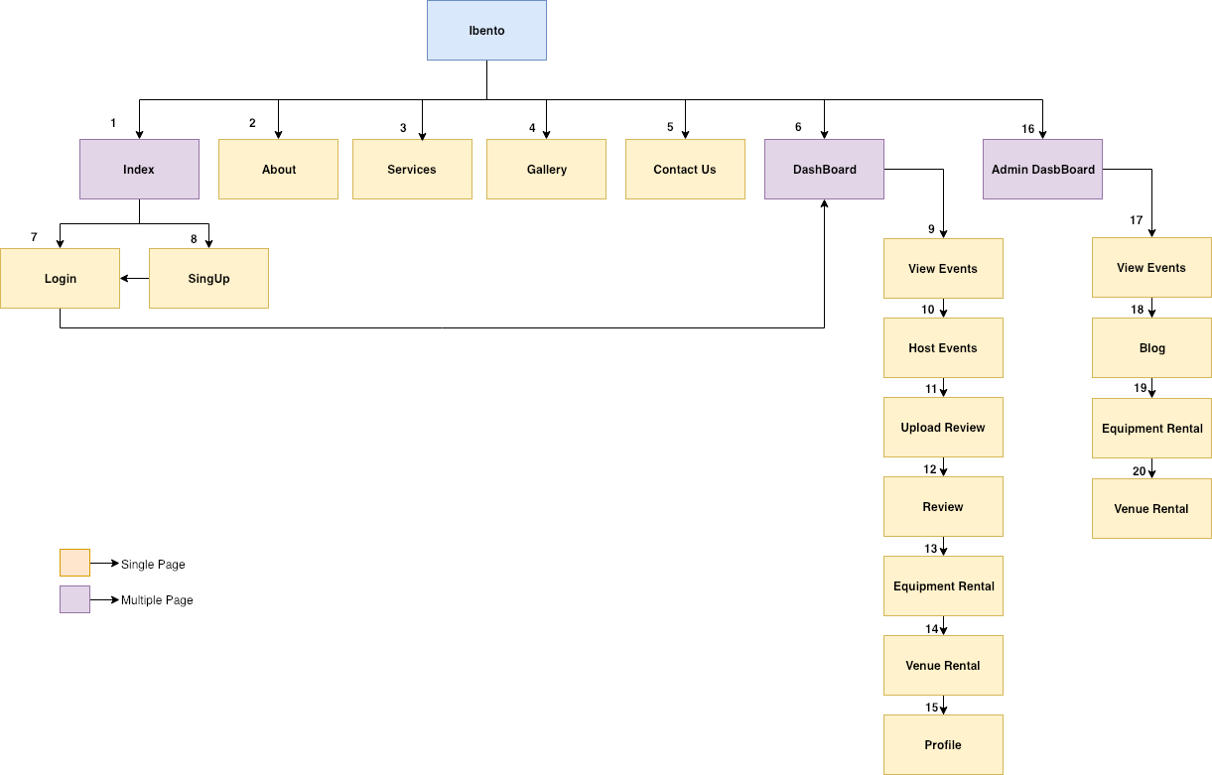

Links to Few Existing Websites

* <https://www.eventene.com/>
* <http://www.exproevents.com/>
* <https://liquidspace.in/>
* <http://www.scorpioevent.com/>

TECHNOLOGY USED:

* BOOTSTRAP
* PARTICLE JS
* JQUERY
* Angular JS
* HTML
* CSS
* GREENSOCKS

**Activity Log**

|  |  |  |
| --- | --- | --- |
| Assigned Page | Description | Name |
| Index | The first landing page when a user visits the website | Aman |
| About | This static page contains details about ibento | Sharan |
| Services | This static page gives the details about the services we can provide | Aman |
| Gallery | This page Contains the Images of all Events Conducted | Rashmi |
| Contact Us | This Page contains Details to Contact Ibeno Office | Pavana |
| Login | This Page is Used to Login and avail the facilities | Rashmi |
| SignUp | Users Have to Register When they are new to the Website | Meghana |
| Dashboard | This is the Landing Page once the user logs in | Aman |
| Profile | This page contains the details of user logged in | Rashmi |
| Events | This Page Contains details of all the events that will be hosted in future | Aman |
| Review | This Page will allow user to post review on certain Events | Pavana |
| Equipment Rental | The facility to rent equipment can be done by filling this page | Sharam |
| Venue Rental | The facility to rent your venue can be availed by filling the page details | Meghana |
| Admin Dashboard | This is the landing page for admin users | Aman |

SCREENSHOTS:

|  |  |  |
| --- | --- | --- |
| No | Name |  |
| 1 | index |  |
| 2 | About |  |
| 3 | Services |  |
| 4 | Gallery |  |
| 5 | Contact |  |
| 6 | Dashboard |  |
| 7 | View Events |  |
| 8 | Host Events |  |
| 9 | Upload Review |  |
| 10 | Review |  |
| 11 | Equipment Rental |  |
| 12 | Venue Rental |  |
| 13 | Profile |  |
| 14 | Admin Dashboard |  |
| 15 | Events |  |
| 16 | Reviews |  |
| 17 | Equipment |  |
| 18 | Venue |  |

REFERENCES:

* Particle js
* GreenSocks
* W3school
* Get bootstrap
* Collect.chat

GROUP MEMBERS:

* AMAN ULLA

   5th Sem CSE    RRCE

* PAVANA

 5th Sem ISE   GMIT

* MEGHANA

 5th Sem ISE   GMIT

* RASHMI

5th Sem ISE   GMIT

* SHARAN H S

5TH SEM ISE  JSSATE